**TECHNICAL ARCHITECTURE**

the receiver **NODE RED** tool for

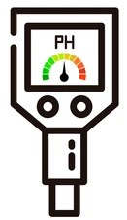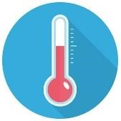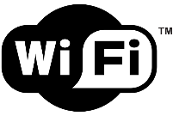

**USER**



**WEB UI**



**PH METER**

**PH M**

**ETER**

Used as

sensor f

or measuring

t

he p

H quality of water

**PYTHON**

**IDLE**

P

ython program

for

giving instruction to

the

mi

cr

opr

ocessor

**T**

**EMPERATURE SENSOR**

For meas

ur

ing

the

**RIVER WATER**

The

natur

al

resource



The

Microprocessor

boa

rd tha

t

a

ct

s

as

the brain

for the

entire s

ystem

**ESP**

**8266**

**Wi**

**-**

**Fi**

**M**

**ODULE**

F

or

I

oT

I

nterface

**CLOUD**

**PLATFORM**

The

d

ata are stored

using

IBM WATSON

CLOUD

pla

t

form

wiring together

devices

&

APIs

**WEB UI**

For

info

exchange through

IoT platform

**MIT APP INVENTOR**

For

making

mobile

a

pp for

data reac

h t

o

**FAST**

**-**

**S**

**MS**

For

sudden alert through

cellular network

temperature in digital value